**ETL Pipeline for Real-Time Data Analytics**

**Objective:**

This ETL (Extract, Transform, Load) Data pipeline is designed to perform real time data analysis. In this pipeline data is extracted from external source (API) , transformed and then ingested into Postgres database.

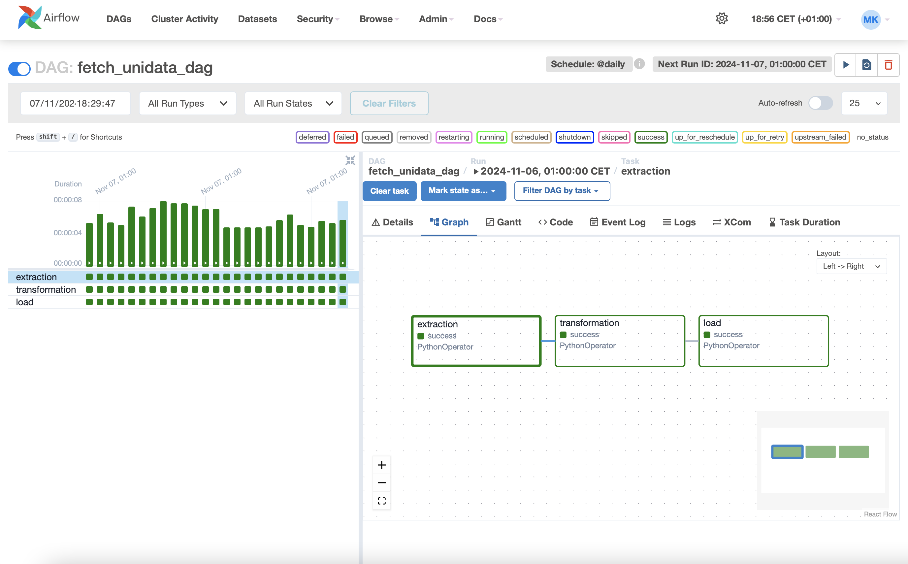

**Tools and Technologies Used:**

* **Apache Airflow**:
* Docker
* Python
* PostgreSQL
* Postgres Hook
* DAGs and Python Operator
* Datetime and Time delta
* Visual Studio Code

**Step#1: Defining Libraries:**

#Libraries/dependencies

from airflow import DAG

from airflow.operators.python import PythonOperator

from airflow.providers.postgres.hooks.postgres import PostgresHook #for connection airflow with postgres database

from datetime import datetime

from datetime import timedelta

import requests

from airflow.models.xcom import XCom

**Step#2: Defining and initializing the DAG:**

initalizing the DAG

default_args = {

'Owner' : 'airflow',

'depend_on_past':False,

}

dag = DAG(

'fetch_unidata_dag',

default_args=default_args,

start_date=datetime(2023,1,1),

schedule = '@daily',

catchup=False,

)

**Step#3: Defining python functions:**

**EXTRACTION:**

#step1:Data extraction from API:

def data_extraction (**kwargs):

url = "<http://universities.hipolabs.com/search?country=United+States>"

response = requests.get(url)

response.raise_for_status()

data = response.json()

if data is None or not data:

raise ValueError("API response is empty or None")

print(data)

kwargs['ti'].xcom_push(key='raw_data', value=data)

**TRANSFORMATION:**

#step2:Data transformation:

def data_transformation(**kwargs):

#need to pull data from xcom:

raw_data = kwargs['ti'].xcom_pull(task_ids='extraction', key='raw_data')

print(f"Raw data received from XCom: {raw_data}")

if raw_data is None or not raw_data:

raise ValueError("No data received from 'data_extraction' task.")

#getting only specified data

transformed_data = [

{

'domains': item.get('domains', []), # Defaulting to empty list if 'domains' is missing

'state_province': item.get('state-province', ''),

'country': item.get('country', ''),

'name': item.get('name', ''),

'web_pages': item.get('web_pages', [])

}

for item in raw_data

]

print(transformed_data)

kwargs['ti'].xcom_push(key='transformed_data', value=transformed_data)

**LOAD:**

#step3: Data load in postgres database:

def data_loading (**kwargs):

#step31 #getting data transformed data from xcom from data_transformation task:

my_data = kwargs['ti'].xcom_pull(key= 'transformed_data',task_ids='transformation')

print(f"Data pulled from XCom: {my_data}")

if not my_data:

raise ValueError("No data received from 'data_transformation' task.")

#step32 #creating a connection of airflow with postgres data_base using postgres hook:

pg_hook = PostgresHook(postgres_conn_id='my_database_conn')

connection = pg_hook.get_conn()

cursor = connection.cursor()

try:

conn = hook.get_conn() # Try to get the connection

if conn:

print("Connection successful!")

else:

print("Failed to connect to database.")

except Exception as e:

print(f"Error connecting to database: {e}")

#step33 create a table with postgres command and execute with cursor:

create_table_query = """

CREATE TABLE IF NOT EXISTS my_table (

domains TEXT[],

state_province varchar(255),

country varchar(255),

name varchar(255),

web_pages TEXT

);"""

cursor.execute(create_table_query)

#step34 insert data into this newly created table and execute it with cursor:

insert_query="""

INSERT INTO my_table (domains,state_province,country,name,web_pages)

values(%s,%s,%s,%s,%s)

"""

for record in my_data:

cursor.execute(insert_query,(record['domains'],record['state_province'],record['country'],record['name'],record['web_pages']))

#step 35 after commiting the data in table.close the cursor and connection:

connection.commit()

cursor.close()

connection.close()

**Step#4: Defining python Operators:**

#defining python operators for carrying the tasks

task_extraction = PythonOperator(

task_id = 'extraction',

python_callable = data_extraction,

dag=dag,

)

task_transformation = PythonOperator(

task_id = 'transformation',

python_callable = data_transformation,

dag=dag,

)

task_load = PythonOperator(

task_id = 'load',

python_callable = data_loading ,

dag=dag,

)

**Step#5: Task Flow:**

task_extraction >> task_transformation >> task_load

**During Extraction, Data In Xcom:**

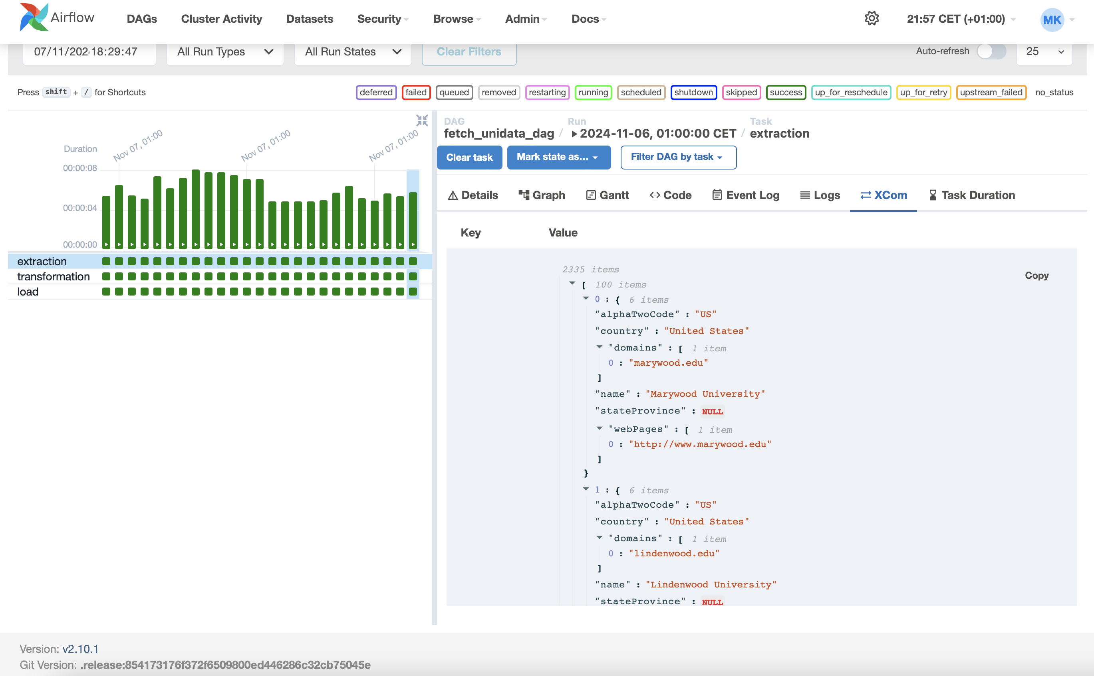

**During Transformation, Data In Xcom:**

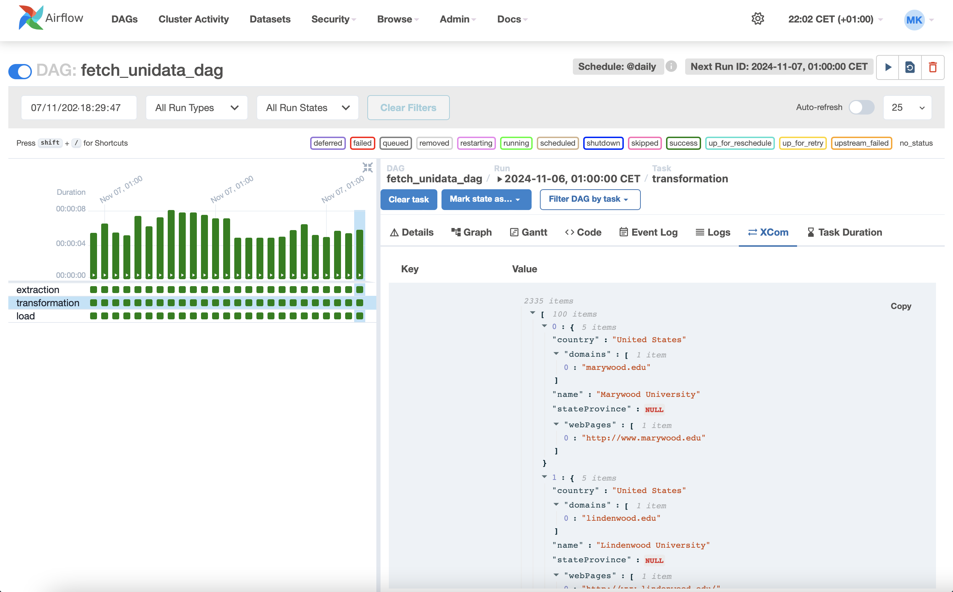

**Task Duration:**

